**Check Gzip Compression Using Browser Developer Tools**

This method is best for those who don’t want to use an external tool to check a website’s Gzip compression.

Follow the steps below to check if Gzip is enabled on a site using a browser:

1. Type the website URL into the browser.
2. Open the browser developer tools or right-click on the page and select **Inspect**.
3. Click on the **Network**tab. You should see all the resources the web server has sent. In case you don’t, reload the page.
4. Select one of the resources to view its content. Click the **Headers**tab.
5. Under **Response Headers**, find **content-encoding**–the compression method used by the site will be listed beside it.

If Gzip has not been enabled, there are two ways to do it. You can either modify the **.htaccess**file or go for a [**WordPress plugin**](https://www.hostinger.com/tutorials/what-is-wordpress-plugin).

**Enable Gzip Compression Using a WordPress Plugin**

The easiest way to enable Gzip on a WordPress website is to [**install a plugin**](https://www.hostinger.com/tutorials/wordpress/how-to-install-wordpress-plugins). It will be a lot easier and safer than modifying the **.htaccess** file.

There are many plugins for this purpose available, but we have chosen these four plugins based on their features and ease of use:

* [**WP-Optimize Cache**](https://wordpress.org/plugins/wp-optimize/)**.** An all-in-one solution to boost website performance. The plugin enables Gzip and [**web caching**](https://www.hostinger.com/tutorials/website-cache). In addition, it eliminates unnecessary files from a website. This tool can even optimize images to free up more space.
* [**Hummingbird**](https://wordpress.org/plugins/hummingbird-performance/)**.** This plugin gives users more freedom to choose which aspects to optimize. Gzip compression, minification, and lazy load offscreen images are some of its main features.
* [**WP Fastest Cache**](https://wordpress.org/plugins/wp-fastest-cache/)**.** This tool combines its caching prowess with Gzip to make pages fast and lightweight. This plugin can also automatically disable emojis and optimize every single post.
* [**WP Rocket**](https://wp-rocket.me/)**.** A web performance plugin equipped with numerous features such as page and browser caching, cache preloading, Gzip compression, eCommerce optimization, and excellent compatibility with popular WordPress plugins, themes, and hosting types.

Since these plugins have more features than just compression, we suggest trying all of them to see which one fits your needs best.

### Enable Gzip Compression Using the .htaccess File

This method of enabling Gzip compression is quite technical, so it’s more suitable for advanced users. However, anyone can do it as long as they’re careful.

This content will show you how to modify the **.htaccess**file using the [**File Manager**](https://www.hostinger.com/tutorials/how-to-use-hostinger-file-manager/) of your [**web hosting**](https://www.hostinger.com/web-hosting) provider’s control panel. We’ll be using Hostinger’s hPanel. However, you can also use an FTP such as [**FileZilla client**](https://www.hostinger.com/tutorials/ftp/filezilla-ftp-configuration).

To enable compression via the **.htaccess**file, follow the steps below:

1. Log in to hPanel and click on **Hosting**on the navigation bar. Then, find your domain name and click **Manage**.

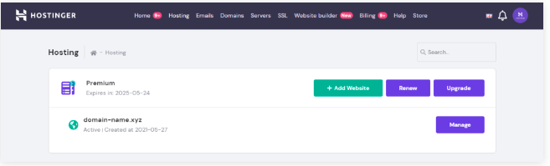

1. Scroll down to find the **Files**section and click **File Manager**.

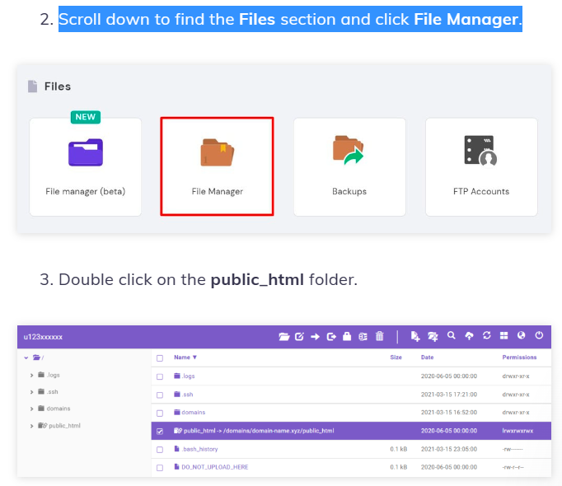

4 Find the **.htaccess**file. Download the file and save a copy on your computer as a backup. Then, double-click on the **.htaccess**file located in the **public_html**folder to open it

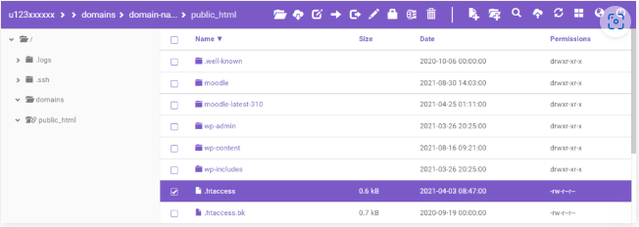

5 Paste the following code into it before the **# END WordPress** line

<IfModule mod_deflate.c>

AddOutputFilterByType DEFLATE text/plain

AddOutputFilterByType DEFLATE text/html

AddOutputFilterByType DEFLATE text/xml

AddOutputFilterByType DEFLATE text/css

AddOutputFilterByType DEFLATE application/xml

AddOutputFilterByType DEFLATE application/xhtml+xml

AddOutputFilterByType DEFLATE application/rss+xml

AddOutputFilterByType DEFLATE application/javascript

AddOutputFilterByType DEFLATE application/x-javascript

</IfModule>

6 Once finished, click the **Save & Close**button